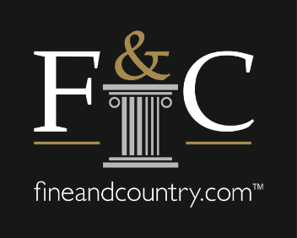

Will the self-employment model be around after COVID-19?
Before the coronavirus arrived on UK shores, there was a growing trend of estate agents moving towards self-employed models. However, with the self-employed seemingly less protected than employees in the emergency measures implemented by the government, could this trend be a thing of the past?

Nicky Stevenson, Head of the Fine & Country Associate platform, a self-employment model launched by the premium estate agency earlier this year, says she believes the opposite. “I actually believe it will go the other way and that employees, especially those left high and dry, will realise that the security of employment they thought they once had, isn’t quite as secure.”

She continues that for many the prospect of leaving the comfort of a job and becoming self-employed has thus far been a daunting prospect for some, and fear has prevented it. “Generally, people are more motivated by fear than gain, so for many the default is to stick with what’s familiar and secure rather than taking a risk to make a gain. On the other side of the COVID-19 pandemic, those that have been left high and dry have less risk and may well believe that now is the opportunity to be their own boss and have more control over their time and earning potential.”

Stevenson adds that over the past few weeks there has been a dramatic shift in the industry with agents having to quickly adapt to the ‘new normal’ of the sector. The current situation has challenged agents and how they think about their businesses. It has raised a number of questions around the traditional estate agency setup and how this can evolve moving forward - now is the time for every business to reimagine business as usual.

“We have already seen a shift in office set ups, with some agents choosing to have one bigger office, rather than various smaller offices in different towns, and sometimes off the high street. We have seen technology evolve to enable virtual working take place easily. The pandemic has forced the industry to embrace certain technology that until now may not have been forefront. COVID 19 has also of course forced everyone to work from home. I don’t think that ‘normal’ as we know it will be the same again and that every agent will be more tech enabled and experienced in working remotely. Now is also a great time to be learning. These ingredients in my opinion, is a great foundation to launch into self-employment,” she explains.

The Associate model provides an opportunity for experienced, entrepreneurially minded agents to own their own business without having the overheads of running a high-street or traditional agency. Low overhead costs and a high earning potential offers an attractive opportunity with more control over your destiny.

To find out more about the Fine & Country Associate Platform register for Nicky Stevenson’s free webinar, which will take place on Wednesday, 8 April at 16:00. Becoming an Associate is available to experienced agents in certain geographical areas, and there is an application/due diligence process. Being an Associate is a commission only role. To attend the webinar, we will ask for your CV to be submitted ahead of time.

-END-
Editors Notes:
Fine & Country specialises in the sale and rental of prime residential properties. The company has offices in 300 locations around the world including in the UK, Cyprus, Ireland, Germany, Mauritius, The Channel Islands, France, Namibia, Portugal, Spain, South Africa, West Africa, Russia, Australia and Hungary. Fine & Country has won Best Estate Agency Marketing and Best International Estate Agency Marketing seven times in the past 10 years at the International Property Awards.

