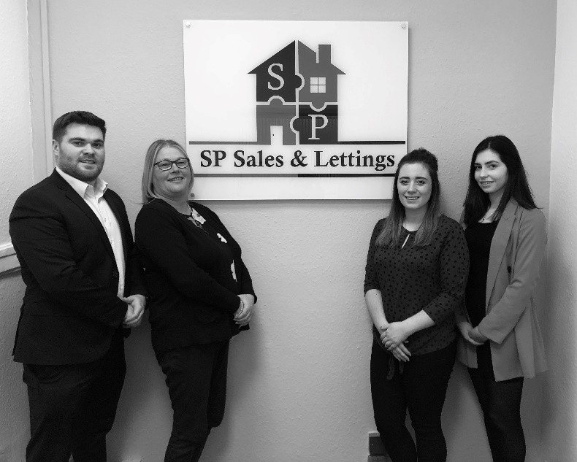

Virtual valuations helped local family agent increase market share
Member of The Guild of Property Professionals and Managing Director of SP Sales & Lettings in Coalville, Sean Pell, says that virtual valuations were a key to his success in being able to grow his market share as the property market surged to life as restrictions lifted. “The boost coming out of lockdown after doing virtual valuations helped us increase our overall market share, going from fourth to second in our area. We were also able to reach the top spot in the area in terms of new instructions and sales agreed,” says Sean.

He adds that his office had a 90% conversion rate of video valuations to instructions. “During lockdown we were able to gain a good number of instructions without actually having to visit the property in person. We would complete a virtual valuation and then provide the vendor with a step-by-step guide on how best to take the photos of the property to ensure they showcase the home in the best possible light. The vendor would then send us the images and we would let them know whether they need to make changes to the angle or other adjustments that would help make the images more appealing to possible buyers,” adds Sean.

Speaking of the office’s high conversion rate, Sean says that it was all about making the public aware that they were available and willing to do virtual valuations, while some agents were not. “There weren’t many agents in our area doing virtual valuations and the ones that were, didn’t seem very enthusiastic about them, which was to our advantage. Two weeks before the lockdown lifted, we saw a boost in activity with people looking to place their homes on the market and we were able to assist them through virtual valuations and got a lot of listings during that stage. We were also able pre-book a lot of viewings for when the lockdown had lifted,” Sean explains.

He adds that since lockdown has lifted the office has seen a massive amount of activity, which Sean largely attributes to the number of customers they were able to assist while still in lockdown. “The virtual valuation tool, along with the advice and services we were able to provide to our customers as Guild Members, helped us gain further traction in our local market and assisted in positioning us a one of the go-to property experts in the area. For example, we were one of the only agents in the area to provide health assessment checks to vendors and buyers, which many within our community appreciated and I think we gained life-long customers as a result,” says Sean.

“We joined The Guild of Property Professionals just before going into lockdown. It wasn’t an easy decision at the time as we are a small business and didn’t want to take on any further expense, however, I can honestly say it has been one of the best decisions we made. The advice and support throughout lockdown helped us to grow and gain market share during a challenging time in the industry, which has been worth its weight in gold,” he concludes.
-ENDS-
Editors’ Notes
The Guild of Property Professionals (The Guild)
The Guild is a network of 800 of the best independent estate agents from across the UK. The Guild is a sign of professional excellence that agents can use to differentiate themselves from their competitors and assure clients that they will act with knowledge and integrity to achieve results, the three core values of The Guild. To allow agents to perform a superior service, The Guild offers marketing, business and technology services to its members.

