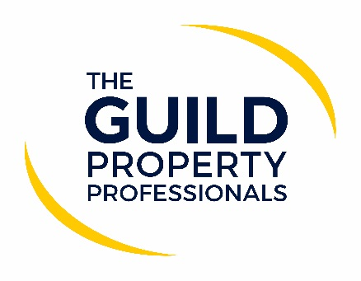

The Guild of Property Professionals issues guidelines for agents returning to their offices when safe to do so
On 16th April, the Foreign Secretary referenced in his Coronavirus update that ‘there was light at the end of the tunnel’. Hopefully, this means that one day, in the not too distant future, the Government and health experts will advise that we have conquered the pandemic and things could start to return to normal – although ‘normal’ may not be quite as we remembered.

According to Paul Offley, Group Compliance Officer for epropservices, the parent company of The Guild of Property Professionals and Fine & Country, the most important thing is to ensure that when we return to our offices, we follow Government guidance are not increasing the risk of a second round of the virus and a further lockdown. We must continue to do all we can to safeguard everyone.

“While we are lobbying for estate and lettings agents to be among the first industries to get back to work, it is paramount that this includes a strict process, strategy and guidelines for working in a safe manner. For the foreseeable future, or at least until COVID-19 is no longer considered a risk to society, the way business is conducted will be different. Estate and lettings agents will ultimately need to change their processes and the way they interact with each other and the public to ensure everyone is protected,” says Offley.

He adds that The Guild of Property Professionals has produced and distributed a guideline document to Members and Licensees outlining best practices for returning to work safely when the Government and health experts deem it safe. “We have put together a document issuing guidance to our network based on the information and best working practices that are currently available and will continue to take advice from the Government has the more comes to light. When lockdown restrictions are lifted, this will hopefully be accompanied by further guidance from the Government on aspects such as conducting viewings, valuations and end of tenancy visits. We will ensure that as more information becomes available our guideline document is updated to keep everyone informed and acting according to the advice of the Government and health experts,” Offley adds.

The document offers guidance on staff interaction, health checks and office set up to ensure social distancing measures, interaction with the public and suggestions for conducting viewings and valuations when a virtual option is not viable. “Our number one priority is ensuring that our Members and Licensees adhere to Government advice and can provide a safe environment for all concerned while they carry out their business. By working together and following some simple yet essential steps, we can all help keep each other safe while getting people moving,” Offley concludes.

The guideline document is available to all estate and lettings agents who wish to download it.
-ENDS-
Editors’ Notes
The Guild of Property Professionals (The Guild)
The Guild is a network of 800 of the best independent estate agents from across the UK. The Guild is a sign of professional excellence that agents can use to differentiate themselves from their competitors and assure clients that they will act with knowledge and integrity to achieve results, the three core values of The Guild. To allow agents to perform a superior service, The Guild offers marketing, business and technology services to its members.

