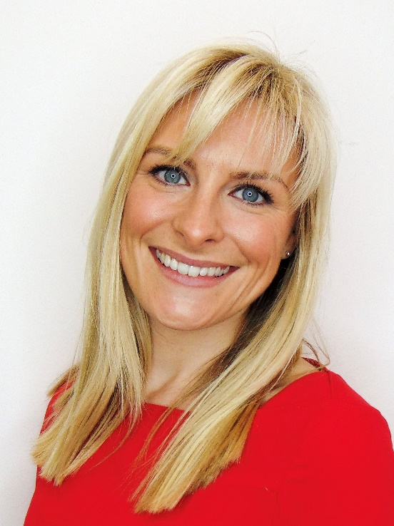

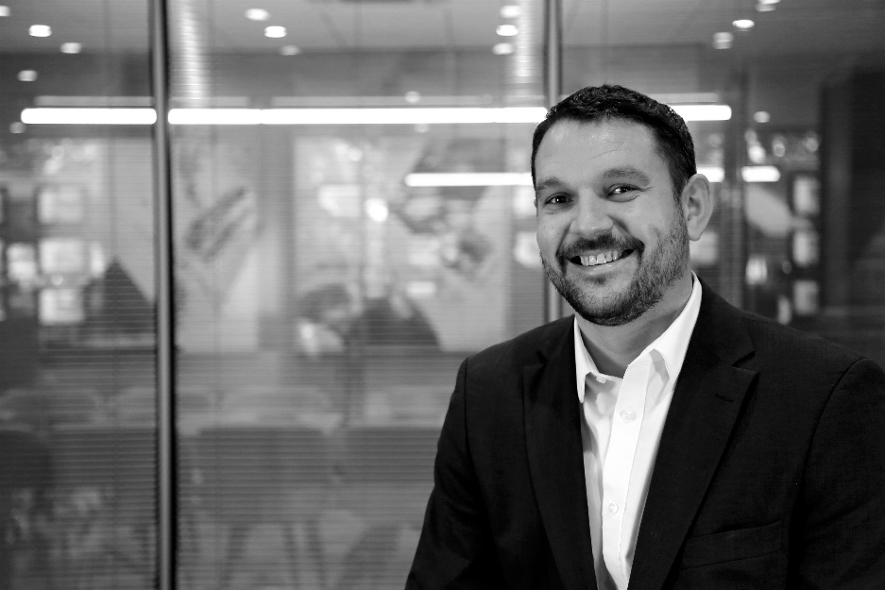

FINE & COUNTRY STRENGTHENS ITS MANAGEMENT TEAM AS IT FOCUSES ON GROWTH

Already the fastest growing premium estate agency in the UK, Fine & Country is looking to further expand and continue growing its UK and international footprint in the premium market.

As part of the new structure, after ten years with the brand, Fine & Country CEO, David Lindley will be stepping down from his post at the end of May to pursue other business interests. Lindley said: “It has been an exciting journey for me with Fine & Country, I have been fortunate enough to be part of this superb brand which has grown rapidly and is now one of the leading names in premium estate agency. I would like to thank all Fine & Country licensees and team members for their support and dedication to the brand.”

To steer the brand to further growth, the Board has appointed Nicky Stevenson as MD of Fine & Country UK and Head of Growth, and Daniel Harrington as Head of Growth London and International.

A well-known figure within the industry, as the former Managing Director of the Property Academy, Stevenson will continue the focus on supporting the UK licensee’s network to grow its market share in the premium market.

“I am delighted to take on the role as Managing Director at Fine & Country UK. We enjoy great relationships with our network of individual agents across the country, and I look forward to building on them over the months and years to come, whilst continuing to evolve our agent benefits through our leading marketing and technology platforms,” says Stevenson. “We are a young and ambitious company, with big growth plans. I am excited to work with the team to build on our already enviable position of ‘fastest growing premium brand in estate agency’ as we seek to further grow the brand across the country.”

She will be supported in the role by Emilie Despois, Head of Fine & Country Marketing, who has been with the brand for the past ten years and has played an integral role in making Fine & Country the fastest-growing premium estate agency brand.

While Stevenson looks after the brand’s UK growth, Daniel Harrington, who has been in the business for five and half years, will be focusing on London and international offices. The international team will be further strengthened by South African based Linda Erasmus as the brand’s international ambassador. Jon Cooke will officiate as Interim Global CEO until a suitable candidate is found for the role.

Cooke says: “On behalf of everyone within the Fine & Country network, we thank David for his remarkable service to the brand over the past 10 years. Without him, the brand would not be where it is today. While we are sad to him go, we wish him all the best for the next chapter in his career.”

-END-
Editors Notes:
Fine & Country specialises in the sale and rental of prime residential properties. The company has offices in 300 locations around the world including in the UK, Cyprus, Ireland, Germany, Mauritius, The Channel Islands, France, Namibia, Portugal, Spain, South Africa, West Africa, Russia, Australia and Hungary. Fine & Country has won Best Estate Agency Marketing and Best International Estate Agency Marketing seven times in the past 10 years at the International Property Awards.

