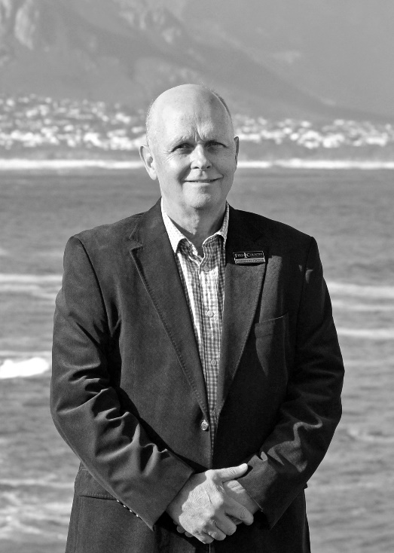

Fine & Country International appoints new CEO in South Africa
As part of their global expansion strategy, premium estate agency Fine & Country International has appointed Stephen de Stadler as the new CEO of Fine & Country South Africa. Stephen will be taking over the role from Linda Erasmus, who has taken on a larger role as the brand’s International Ambassador, assisting with expanding the brand’s global reach.

An accountant by profession, Stephen competed his Articles of Clerkship at KPMG Aiken & Peat and was employed as Financial Manager and then Financial Director for one of the major estate agency brands in South Africa (Seeff Properties). This property experience led to his appointment in the Corporate Division of a major South African bank (Nedbank), where initially he was responsible for the credit aspects relating to a significant property portfolio, but ending his tenure there as head of credit for Sovereigns and Banks.

This credit experience resulted in an appointment by an international rating agency (Fitch Ratings), firstly as Managing Director of their Sub-Saharan African operation, followed by his appointment as Managing Director and Regional Head for the Middle East, based in Dubai.

Following Stephen’s return to South Africa from Dubai in 2011, he became directly involved in Public Sector Infrastructure Development and Financing, as an executive management consultant.

“I have been engaging at executive level across a wide range of Sovereigns, Sub-sovereigns, Corporate Entities, and Financial Institutions for the last 30 years. These interactions have provided me with the ability to communicate effectively and efficiently in any business environment. I bring a thorough understanding of financial markets and financing solutions to any environment, together with a detailed understanding of, and experience in, business development and senior level executive management,” says Stephen.

In 2018, he decided to enter the property market in his own right. “Following an assessment of local market conditions, I decided that the Fine & Country brand was the one which delivered the level of professionalism and expertise that I would require to make a success of this new business venture. I was delighted to reunite with the then CEO of Fine & Country South Africa, Linda Erasmus, who I have known on a business and personal level for 28 years. Both Linda and I started our property careers at Seeff Properties back in the early 1990’s,” says Stephen.

Speaking of how he intends to grow the Fine & Country brand moving forward, Stephen says: “South Africa has a myriad of estate agents, but the mantle of being a premium real estate concern is limited to only a few. Fine & Country has a truly international base, and therefore an undoubted ability to provide superior local and international exposure. My vision is to establish the brand as the first-choice premium brand in South Africa. This will be accomplished by fully incorporating the local operations into the global network and providing them with the tools required of a modern-day estate agency.”

Jon Cooke, Global CEO of Fine & Country, says: Jon Cooke, Global CEO of Fine & Country, says: “We are excited about Stephen’s appointment and the vision that he has for Fine & Country South Africa. The calibre of his business experience and Linda’s exemplary property sales record in South Arica are a winning combination for the brand and I believe Stephen is the ideal person to steer the brand into the next phase of its growth. We are confident that the South African region is in good hands.”

In conclusion, Stephen says: “I am truly excited to be given this opportunity to ensure that world class service is delivered to my country. As South Africans we are stronger together, and as part of the Fine & Country family we are also stronger together.”

-END-
Editors Notes:
Fine & Country specialises in the sale and rental of prime residential properties. The company has offices in 300 locations around the world including in the UK, Cyprus, Ireland, Germany, Mauritius, The Channel Islands, France, Namibia, Portugal, Spain, South Africa, West Africa, Russia, Australia and Hungary. Fine & Country has won Best Estate Agency Marketing and Best International Estate Agency Marketing seven times in the past 10 years at the International Property Awards.

