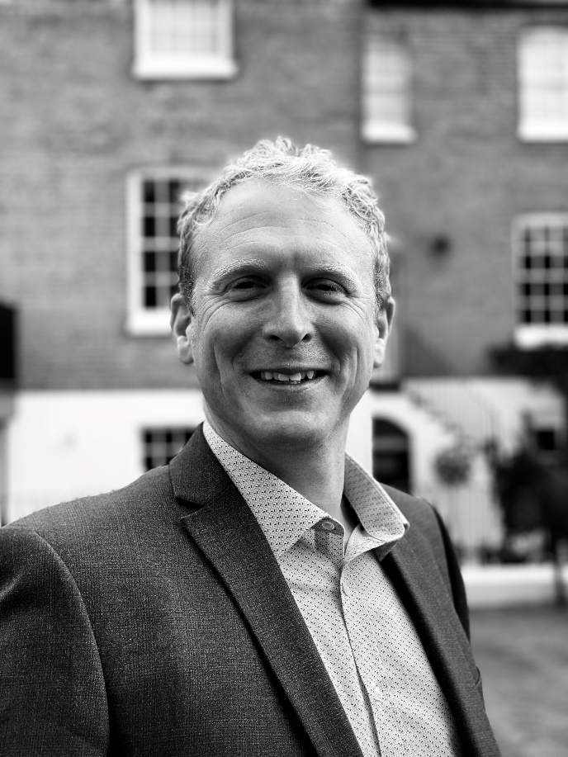

Fine & Country appoints new director to realise vision of further growth
The fastest growing premium estate agency brand in the UK, Fine & Country has its sights set on further expansion, appointing Jonathan Handford as a Director of Fine & Country UK to assist with achieving its goal of becoming the largest premium estate agency in the UK.

Since the property market was allowed to reopen in May the premium property sector has seen exceptionally high volumes of activity, which has had many agents refocusing their attention on the upper quartile of the market. This has led to an increased interest in the brand which has enjoyed growth throughout the country. To continue the momentum and assist Fine & Country in reaching the number one spot in the premium market, the brand has made several key appointments with Nicky Stevenson stepping into the role as MD of the UK, and with Daniel Harrington heading up London and its international operation. Handford’s appointment as Director will further strengthen the team.
As an experienced international speaker, coach, trainer and estate agent, Handford, has a wealth of knowledge that he can offer licensees. He is committed to the upper quartile of the market focussing on luxury property and was recognised in 2019 as the Best Overall Operator from 325 Fine & Country offices across the world. As the Managing Director of Fine & Country Leamington Spa, Handford is well versed with both the brand and with what agents require to be a success.
Speaking about his appointment, Handford said: “It’s difficult to convey just how proud I am to be an ambassador of Fine & Country. I have been fortunate to work with the brand for over 15 years. I feel my affiliation and partnership with the business has been a significant contributing factor to my own personal success,” he adds, Upon seeing the growth and expansion strategy for Fine & Country moving forward I knew that I wanted to be part of this at board level. I am hoping to bring my experience from the coal face to assist new and existing Fine & Country agents to maximise the opportunities in their marketplace. We have a proven strategy, and the power of the global network to cement our position as the agent of choice for the upper quartile and luxury property market across the world.”
Jon Cooke, Global CEO of Fine & Country, says: “We are pleased to be able to have Jon join the executive team at head office to help drive growth and assist us with achieving our vision for the brand. As a licensee who has been with Fine & Country for over 15 years, Jon understands the brand’s unique offering and how it can assist agents to position themselves as the go-to premium agent in the area. His expertise and knowledge are a true asset to our brand and the management team.”

Nicky Stevenson, MD of Fine & Country UK, says “I am delighted to welcome Jon Handford to the Fine & Country management team. His in-depth experience as a Fine & Country agent will be invaluable in supporting our increasing number of Associates and Licensees in the network.”

-END-

Editors Notes:

Fine & Country specialises in the sale and rental of prime residential properties. The company has offices in 300 locations around the world including in the UK, Cyprus, Ireland, Germany, Mauritius, The Channel Islands, France, Namibia, Portugal, Spain, South Africa, West Africa, Russia, Australia and Hungary. Fine & Country has won Best Estate Agency Marketing and Best International Estate Agency Marketing seven times in the past 10 years at the International Property Awards.

