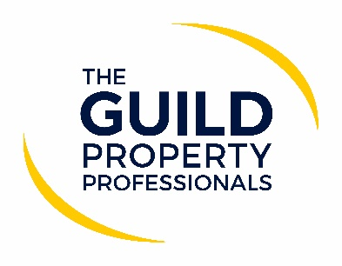

85% of agents believe an office is still important
While much has been said about a ‘new normal’ and a new way of conducting business, eight out of ten agents still believe that a physical office is a vital aspect to their business. Although agents have had to quickly adapt to working in lockdown and maintaining their business remotely, most say that they will be returning to their offices once the Government has advised that it is safe to do so.

Iain McKenzie, CEO of The Guild of Property Professionals, said that a survey was sent to Guild Members asking whether they would consider alternative ways of working and whether they would be reopening their physical offices once the lockdown restrictions had eased. “While most said that their office environment would need to be set up differently to ensure social distancing restrictions and health guidelines were adhered to, the majority were hoping to return to their offices and keep their agency model as it was,” notes McKenzie. “Although websites, portals, social media, and more recently virtual viewing and valuation tools, are key elements to the estate agency, many still feel that a physical office presence and being able to interact with the public will remain a large part of their business going forward, even with social distancing measures in place. While the sector has quickly adapted to using technology and virtual tools, something that may have been considered a gimmick a mere few month ago, the reality is that estate agency will always be a people business.”

The results are not surprising considering most independent agents are a single branch high street agency that are the backbone of their local property market and an integral part of their community. As a single branch operation, what would be the alternative working situation other than to reopen their office? A large portion of the agents believe that the presence of a high street office will continue to enhance their brand. It is important to many house buyers, who want to speak to a property professional in person before making the decision to sell their home.

When asked if they would consider a hub style agency in the future with agents working remotely, the respondents were spilt. Half said it could be something they would consider in the future, while half said they were happy with their current model and wouldn’t want to change. “While most of our network regard a physical office as important, it seems that many are open to change as things progress and the market settles into a new post-COVID-19 normal. Around 53% of Members said that they would have fewer desks in their offices, with approximately a third saying they would enable some of their employees to work remotely on a permanent basis. If the last few months has taught us anything, it is that agents need to be adaptable, ready to innovate and of course resilient,” says McKenzie.

He adds that when agents are allowed to return to their offices, whatever that may look like, the most important thing is to ensure everyone’s safety is a priority. “It is vital that all sectors returning to work to do so safely. Following Government guidance, we’ve worked closely with the Ministry of Housing, Communities and Local Government to develop the six-point guide for estate and lettings agents returning to work. Our number one priority is ensuring that our Members adhere to Government advice and can provide a safe environment for all concerned while they carry out their business. By working together and following some simple yet essential steps, we can all help keep each other safe while getting people moving,” McKenzie concludes.

You can download The Guild’s Six-Point Return to Work Guide here.
-ENDS-
Editors’ Notes
The Guild of Property Professionals (The Guild)
The Guild is a network of 800 of the best independent estate agents from across the UK. The Guild is a sign of professional excellence that agents can use to differentiate themselves from their competitors and assure clients that they will act with knowledge and integrity to achieve results, the three core values of The Guild. To allow agents to perform a superior service, The Guild offers marketing, business and technology services to its members.

