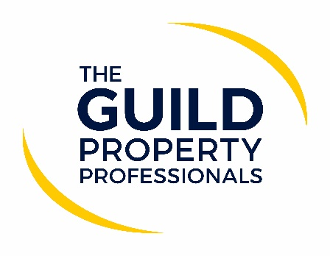

For now, home moves have the green light
In a bid to address the rapid rising number of Covid-19 infections, Prime Minister, Boris Johnson has announced a new three-tier lockdown system in the UK. Under the new system areas of England will be divided into classes of medium, high or very high risk and will be placed under restrictions based on the level of severity of infections experienced in the region.

Paul Offley, Compliance Officer at The Guild of Property Professionals, says that Tier Three, which is the most severe, would include the closure of pubs, restaurants, and leisure facilities. However, for now, the latest local restrictions introduced in England do not appear to have impacted on the home moving process and estate and lettings agents can continue to support sellers, buyers, landlords and tenants by facilitating their home moves in a Covid-19 secure manner.

“The Guild has already updated and issued its Home Moving Process document, which guides agents to ensure they are operating in a Covid-secure way and supports them on all processes and procedures. As an organisation, we continue to monitor the situation on a daily basis, but as it stands at the moment the Government has given no indication that people cannot go ahead with their plans to move,” says Offley.

He adds that while there has been no mention by the Government of the property industry specifically, as an industry that works within people’s homes, adhering to the health guidelines and keeping people safe is paramount for estate and lettings agents. “No agency wants to be seen as the reason a particular area has been upgraded to a tier two or three. Agents have a responsibility to their customers and staff to ensure they are following the procedures required to keep everyone safe,” Offley comments.

What should agents be doing?
- Be aware of the tier level in your area and review what this means for your business should your area see a rise in COVID-19 confirmed cases.
- Work from home where you can.
- Make any premises ‘COVID-secure’ – visits by appointment only; social distancing in place and increased hand washing and hygiene processes in place.
- Promote virtual – this includes, valuations, viewings, meetings, negotiations, inspections, check outs etc.
- Face to Face meetings – always follow COVID-secure – social distancing and use PPE where required.
- If you are tested as positive, you will need to be able to recall those people who you came into close contact starting 48 hours prior to your symptoms so that the ‘trace’ part and be effective, so make sure you have clear records of these contacts.
- Where you have more than one confirmed COVID-19 case in your workplace you are required to inform your local health protection team as this would be classed as an outbreak.
“The tier system and guidelines that pertain to each level are in place for everyone’s protection. It is really important that all agents take all reasonable steps and follow Government guidance,” Offley concludes.

Download the Home Moving Guide here.
-ENDS-

Editors’ Notes
The Guild of Property Professionals (The Guild)
The Guild is a network of 800 of the best independent estate agents from across the UK. The Guild is a sign of professional excellence that agents can use to differentiate themselves from their competitors and assure clients that they will act with knowledge and integrity to achieve results, the three core values of The Guild. To allow agents to perform a superior service, The Guild offers marketing, business and technology services to its members.

