Premium estate agency opens in Mallorca the jewel of the Mediterranean

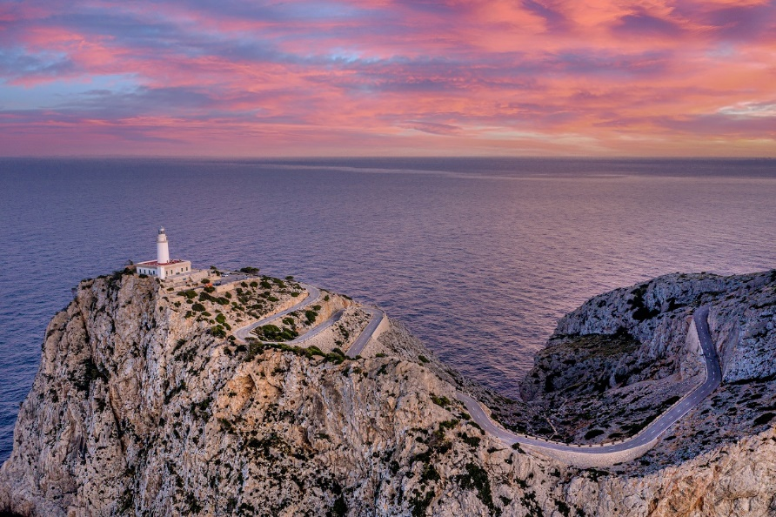
Premium estate agency, Fine & Country will be launching a new office on the Balearic Island, Mallorca. Opening its doors on 1 June 2021, Fine & Country Mallorca will be operated by Managing Director, Rick Flay, who has 30 years of property experience as a successful estate agent, investor, and finance provider for both residential and commercial property. He has a proven record of being able to maximise the marketing choices for prestige property to ensure its exposure reaches the widest audience and the maximum possible value is achieved.

Fine & Country Mallorca will cover the whole island, which has a population of around 900,000, with approximately 400,000 living in the greater Palma area. To start, the office will consist of Rick Flay and three other staff members with the plan to recruit multi-lingual sales agents. The plan is to expand the Mallorca office and then open a second office in Menorca later this year,” he says. “As a popular holiday destination, Mallorca is sought after holiday-home hotspot with a diverse cliental. While there are many Spanish speaking residents on the island, we also have a large number of foreign buyers looking to purchase second homes. Buyers in Mallorca tend to be German, Swiss, Dutch, Scandinavian, and Belgian who are not affected by Brexit. We are of course also hoping to see the number of British visitors increase as travel restrictions are lifted, as traditionally they have been the second biggest market after the Germans.”

According to Rick, property prices in Mallorca are expensive compared to the most of Europe, which is largely due to its lifestyle appeal. “The island offers a wide variety of properties from large prestige homes, fincas, rural estates and golf properties, to new build apartments. Luxury properties start over €1 million and go up over €30 million. Prices in Mallorca are holding up and hopefully we will be ready to coincide with the upturn of visitors. The island is regarded as the jewel in the crown of the Mediterranean, with the Sunday Times voting it as the best place to live, so lifestyle is a major attraction,” says Rick.

Speaking about why he wanted to join Fine & Country, Rick says that he wanted to work with an upmarket brand and a strong growing network. “Working with a premium, recognisable brand will help our new office quickly gain traction in the upper quartile of the Mallorca market. As mentioned, we have a large number of foreign buyers in Mallorca, many of whom are from countries where Fine & Country has a strong presence. Fine & Country branding and the fact that there are over 300 offices worldwide will be a massive help. When listing their property with us, customers will know that they exposed to an international network of offices with potential buyers, which will be an amazing competitive advantage,” he adds.

Nicky Stevenson, Managing Director of Fine & Country UK, says: “We welcome Rick and his team into the Fine & Country family and are very pleased that the brand continues to grow. The growth of our international network means that there are more opportunities for global referrals, which is an advantage to both our clients and agents alike. We are excited to see what the future holds for the new office in Mallorca.”
-END-
Editors Notes:
Fine & Country specialises in the sale and rental of prime residential properties. The company has offices in 300 locations around the world including Hong Kong, South Africa and Australia. Fine & Country has won Best Estate Agency Marketing and Best International Estate Agency Marketing seven times in the past 10 years at the International Property Awards.

