International expansion continues for premium estate agency brand
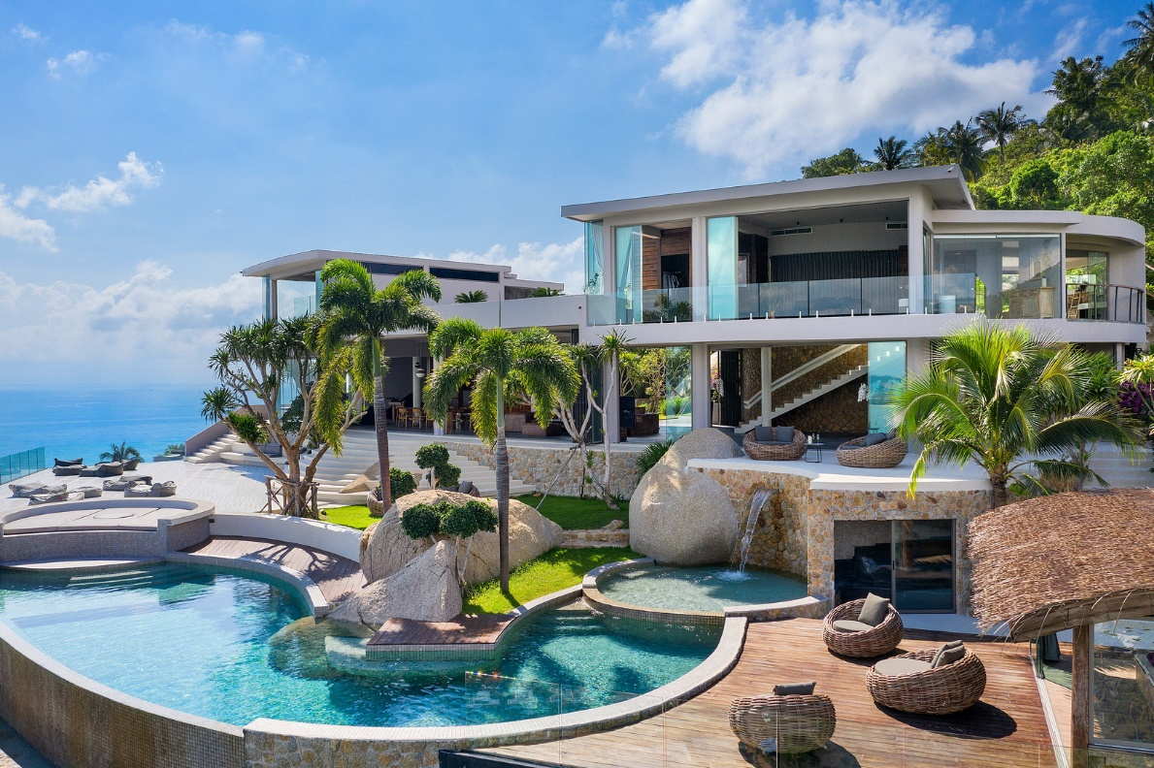
Pushing international expansion and once again venturing into uncharted territory for the brand, premium estate agency Fine & Country has signed its first license in Thailand. Officially launching on the 1st of July 2021, Fine & Country Thailand will be operated by Sean Barrett, who joined the Fine & Country network as a licensee in the UK in late 2019.

When asked why he wanted to open an office in Thailand, Barrett said: “Firstly we love Thailand, the culture and their people. Secondly, we believe the combination of our bespoke marketing strategy with the incredible homes on offer will generate superb results for our clients and last but not least, we have huge client base already in place in Thailand and believe that by bringing Fine & Country to them we will further strengthen relationships and of course hope to create many more.”

He continues saying, Thailand is the second largest economy in the Association of Southeast Asian Nations (ASEAN), and is an upper middle-income country with pro-investment policies. Thailand continues to offer more incentives to invest in advanced technologies, innovative activities and research and development through the Investment Promotion Act, and the Eastern Economic Corridor (EEC) Act, which offers benefits to investors in this zone such as tax subsidies, right to land ownership and issuing of visas. “We believe that such policy improvements will further encourage investors to look at Thailand as a logical destination for investment,” says Barrett. “The luxury market is predominantly driven by overseas investment which due to strict travel restrictions has meant that there is huge pent-up demand, and we anticipate an incredibly active market once travel resumes. Some positive news is that Phuket will open to international visitors with no need for quarantine as part of the ‘Phuket Sandbox’ pilot scheme. Initially this only applies to fully vaccinated travellers but is a huge step in the right direction.”

According to Barrett the profile of buyers for the homes which they will be working with are affluent nationals looking for holiday homes as well as international buyers predominantly from Hong Kong, Scandinavia and the UK. “The office will be focusing on properties that start at £650,000 and go all the way up to £7 million. These are luxury villas in Phuket and Koh Samui as well as some incredible apartments in Bangkok,” he comments.

Barrett adds that he already has a team of 14 on the ground in Thailand and is looking to increase this over the next 12 months to 30. The office is based in Royal Phuket Marina, with plans in place to open a second office in Bangkok within three months. “Our team will be supported by our incredible set-up here in the UK who are highly skilled in selling prime and super prime properties to high-net-worth individuals from across the globe,” Barrett comments. “We are in the early days and already the brand has been received amazingly well in Thailand. We already have over 26 listings without officially opening and aside from clients loving our approach to marketing, our global coverage with key locations in Hong Kong, Germany and of course London have been of huge appeal. This initial success is testament to the global power of the Fine & Country brand, a reason I decided to work with the brand in the first place. I started with Fine & Country in November 2019 and quickly realised the power of the brand. Even during the initial stages of the pandemic, the support from Fine & Country was immense and allowed us to grow substantially in a period of huge uncertainty for many agents.”

Daniel Harrington, Head of International Growth at Fine & Country, says: “Within a relatively short space of time Sean has taken his office in the UK from one level of success to another, and we have no doubt he will do the same with this new venture in Thailand. We are very pleased to be expanding the international reach of the brand and growing our global referral network. We wish Sean success and are eager to see the Thailand region flourish.”
-END-
Editors Notes:
Fine & Country specialises in the sale and rental of prime residential properties. The company has offices in 300 locations around the world including Hong Kong, South Africa and Australia. Fine & Country has won Best Estate Agency Marketing and Best International Estate Agency Marketing seven times in the past 10 years at the International Property Awards.

