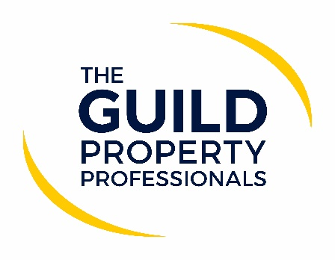

The Guild prepares for it much-anticipated formal qualification launch
Since The Guild of Property Professionals announced its intention to offer Ofqual-accredited, Level-Three and Level-Four qualifications for estate and lettings agents, much work has been going on in the background.

According to Paul Offley, The Guild’s Compliance Officer, Prop Qual, has just under 600 individuals working in Guild Member offices who have now registered their interest to complete the Level-Three qualification, making it one the organisations most supported and anticipated launches to date.

Offley, who will be responsible for the initiative, along with The Guild’s Head of Engagement and Development, Jennifer Scott-Reid, says: “We have had an amazing response from many Members within the network, who eagerly await the launch of the qualification platform. Offering formal qualifications is something that the network has asked for and we are hard at work making sure that we are going to deliver a platform that will provide agents with the training they desire and will help further raise the standards within the sector.”

He adds that The Guild will be using Moodle, an open-source learning platform, to help deliver the learning activities. “We wanted the learning and route to qualification to be one where it’s not just a case of selecting an answer from a selection of options, but rather about making sure agents ‘understand’ the question and the actions they need to take. It is for this reason, that we have decided we will be using assessments as our qualification criteria; getting agents to explain their actions and responses to specific questions. We are working with an established training company to ensure that all assessments are completed by a qualified assessor,” Offley comments. “All the training material has now been written and videos produced, and we are now working on creating our own ‘Moodle’ experience, as well and building all the processes to make the qualification journey straightforward for users.”

He continues: “The other important part is that we wanted to create learning material, which was appropriate for the end users, especially reflecting some variances in legislation across England, Wales, Northern Ireland and Scotland. So, to help us we are recruiting a team of industry experts from our Membership who will form a quality and control panel, assisting us in reviewing the learning material to effectively confirm it is fit for purpose.”

In conclusion, Offley says: “It really is such an exciting time to be able to offer an alternative route for agents to achieve a formal qualification and really to help individuals achieve greater results from their chosen career.”

ENDS
The Guild of Property Professionals (The Guild)
The Guild is a network of 800 of the best independent estate agents from across the UK. The Guild is a sign of professional excellence that agents can use to differentiate themselves from their competitors and assure clients that they will act with knowledge and integrity to achieve results, the three core values of The Guild. To allow agents to perform a superior service, The Guild offers marketing, business and technology services to its members.

