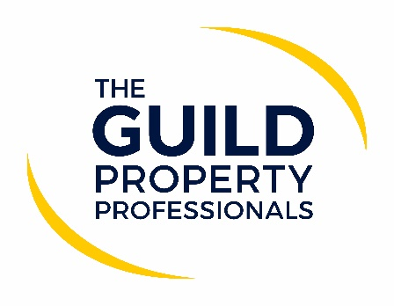

Guidance for home buying and moving process published
The Ministry of Housing, Communities & Local Government (MHCLG) has just published its latest updated home moving guidance for England in step 4 of the roadmap out of lockdown, following the changes to restrictions on Monday, 19 July 2021. The guidance lays out advice to both the industry and those who are moving home, urging all parties involved in a property transaction to continue to follow general hygiene practices and ensure everyone’s safety.

Paul Offley, Compliance Officer at The Guild of Property Professionals, says there are no great surprises in the guidance and many agents had already made the decision to keep many of the COVID measures in place for the safety of the public and their colleagues. “So many lives have been impacted by the pandemic and many were apprehensive to drop the restrictions, whether they were Government mandated or not. While we are all looking forward to a return to some normality, it is also important that we do not un-do the good work achieved but learn to live with COVID in our day to day lives,” says Offley.

He adds that while much of the guidance is voluntary, there are aspects that agents in England should consider during this next stage:

- The ‘work from home’ guidance
Offley says that while the ‘work from home’ guidance will now be lifted, agents should think about how this is going to work in their business. “Many firms are experiencing benefit from different working patterns; so, whilst the guidance is lifted, it is not mandatory, and firms should decide for themselves what is right for their business and their teams. Be mindful also that the requirement to self-isolate for anyone coming into contact with a person who tests positive could have an impact on your business if you have everyone back in the office,” he advises.

- Self-Isolation
Offley says that agents should remind members of their team that if they are contacted by NHS test and trace, they must continue to follow any self-isolation period. “Make it clear when arranging any appointments that these should not go ahead if any party has been advised to self-isolate or awaiting test results,” he adds.

- Face coverings
Everybody will react differently to this. While some will be ready to venture out without one, others will be less inclined to do so. “It will be important to respect everyone’s decision either in the office or on appointments. It is advisable to ask the question ‘would you prefer us/your viewer to wear a face covering at the appointment,” Offley suggests.

- Hand washing
We’ve all got used to carrying with us our little bottle of sanitizer and using these on entering/leaving shops and premises – agents should keep this up, as it is massively helpful in preventing the spread of the virus and will put a lot of people at ease.
According to Offley, there are many agents who received instructions from clients because they felt safe using that particular agent. “Agents put controls in place to allow business to continue in a safe way, making customers feel at ease and making them feel safe. While the Government restrictions may no longer be in place, the need to feel safe will be,” he adds

Offley provides his top 6 tips that agent can use with their customers:
- We will not attend work or any appointment if we are feeling unwell or have been advised by NHS test and trace to self-isolate. The same applies to any visitor to our offices.
- We will ask you if you wish ‘face coverings’ to be worn on any appointment or meeting and we will respect your wishes.
- We will ask you if you prefer to receive only digital communication from us rather than paper copies.
- We will continue to record names and dates of contacts in case of any NHS test and trace position.
- We will continue with our hand washing/sanitizing to reduce the risk of spreading the virus.
- Our priority is always the safety of our customers and our colleagues.

-ENDS-
Editors’ Notes
The Guild of Property Professionals (The Guild)
The Guild is a network of the best independent estate agents from across the UK. The Guild is a sign of professional excellence that agents can use to differentiate themselves from their competitors and assure clients that they will act with knowledge and integrity to achieve results, the three core values of The Guild. To allow agents to perform a superior service, The Guild offers marketing, business and technology services to its members.

