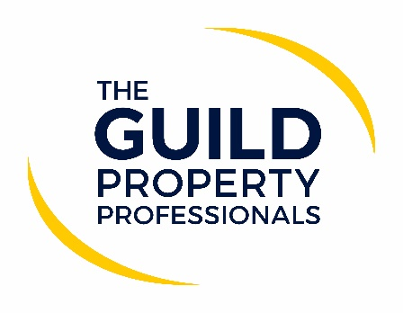

Avoiding penalties – the importance of compliance
It is best to avoid penalties. This is especially true when it comes to financial penalties against a business for non-compliance.

Paul Offley, Compliance Officer of The Guild of Property Professionals, says that regardless of what people do for a living there is some aspect of legislation or compliance that governors their chosen profession, and as all property professionals would know, estate agency is no different. “When it comes to the property sector, what we need to be mindful of is that estate agency compliance is all there for a very good reason and that is to protect consumers. We are all consumers in some form, and we all want to make sure that if a member of our family were buying, selling or renting a property they would be treated fairly and with respect,” he adds.

“With regard to penalties and fines, I think some agents think that it will never happen to them, and because they have done something in a certain way before, they can carry on doing it that way regardless of whether it is compliant or not, and on occasions an agent may claim as a defence ‘well no other agent in this town does it’. However, we have seen that with the increase of complaints and claims and with enforcement and fines within the sector, that simply is not the case and agents who are lax about compliance run the risk of incurring a possibly crippling financial penalty,” says Offley. “That said, compliance should not prevent business opportunities and restrict agents’ entrepreneurial skills, but rather ensure that they are conducted in the correct manner and according to legislation.”

Offley says that while the majority of estate agents would not knowingly act in a non-compliant manner, because there are so many facets within an estate agent’s job that need to be considered, it is very difficult to consistently ensure that all aspects and issues are handled in the right manner at all times. “With the vast number of plates that agents need to keep spinning, it is possible that one plate could stop and if left unchecked the plate that has stopped spinning becomes the norm and that’s where issues arise. To avoid this happening, agents should do a regular compliance checks to ensure all aspects of their business is being dealt with in the right way, and if not, it is important for them to reassess what needs to be done to get their business back on track,” Offley comments.

“As part of the Guild Membership, we work with our network of agents to ensure Members are compliant and have the processes in place to keep them on the right path and to provide a valuable due diligence service. Our aim to shield our Members from a possible compliance breach, while protecting the clients they work with and ensuring the entire process is undertaken in the correct manner. Ultimately, as an organisation our goal is to rise standards within the industry and assist agents to be seen as the professionals they are,” says Offley.

-ENDS-
Editors’ Notes
The Guild of Property Professionals (The Guild)
The Guild is a network of the best independent estate agents from across the UK. The Guild is a sign of professional excellence that agents can use to differentiate themselves from their competitors and assure clients that they will act with knowledge and integrity to achieve results, the three core values of The Guild. To allow agents to perform a superior service, The Guild offers marketing, business and technology services to its members.

