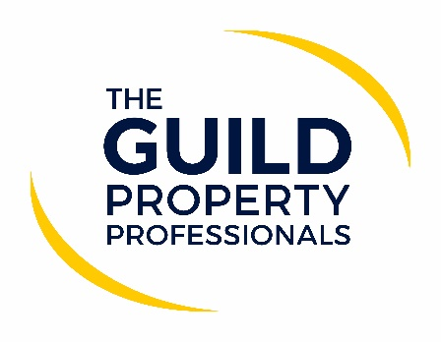

Safe agents increase market share faster
While home moves can continue during the current lockdown, raising infection rates and fears around the new variant of Covid-19 could have an impact on consumer behaviour, as well as the decision they make regarding which agents they choose to deal with. This is according to Iain McKenzie, CEO of The Guild of Property Professionals, who believes that agents with a clear Covid-safe policy and virtual viewing tools will be the ones that people choose to work with.

McKenzie notes that he believes that Guild Members are among some of the safest agents operating in the UK, due to the extensive Covid-safety policies and guidance they have in place, along with the multitude of services and tools they have at their disposal to operate virtually. “Since the initial lockdown in March last year, along with our safe working guides we also introduced a number of virtual tools that allow Guild Members to work both efficiently and effectively within a Covid-safe way, which I believe has been the reason the Guild continued to see its market share grow throughout 2020 in terms of instructions received. Guild Members received 89,259 instructions in 2019 and 91,063 in 2020, which is significant considering the market was shut during the initial lockdown. The public want to work with businesses and agents that put their health first, which is evidenced in the market share growth our independent agent Members experienced in 2020,” McKenzie comments.

“I’ve read a lot of dialogue from estate agents saying that virtual tools don’t matter, but I believe those that say that are not listening to their customers. That fact that Covid-safe agents using virtual tools have seen an increase in market share points to the fact that it does matter. If customers who have a property to sell think that virtual tools matter, it should matter to agents,” says McKenzie. “And that was before the new strain of Covid-19. With the new variant being so much more transmissible these tools are only more likely to be important in the first quarter. As soon as the vaccine starts to take effect, of course we could see consumer behaviour might revert to type and go back to the old world but do agents really want to miss three months of activity.”

He continues saying that estate and lettings agents need to be promoting their Covid-secure-policies and measures they are taking to ensure the public’s safety. “This will firstly put people’s minds at rest if they have concerns and secondly it will help agents set themselves apart from others within the industry who may not be as stringent in their approach when operating during the lockdown,” McKenzie comments.

“While the sector is one of the few that are remain open during this lockdown, it is not business as usual and agents should be acting in a way that protects their customers as much as possible. Everyone has a responsibility to reduce the transmission of the virus allowing society to return to as near normal way of life as possible,” McKenzie concludes.

-ENDS-

Editors’ Notes
The Guild of Property Professionals (The Guild)
The Guild is a network of 800 of the best independent estate agents from across the UK. The Guild is a sign of professional excellence that agents can use to differentiate themselves from their competitors and assure clients that they will act with knowledge and integrity to achieve results, the three core values of The Guild. To allow agents to perform a superior service, The Guild offers marketing, business and technology services to its members.

