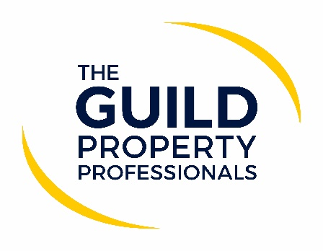

Legal and estate agency group heads call for agents and lawyers to collaborate
With the Stamp Duty Land Tax (SDLT) holiday deadline fast approaching and the inevitable pressure that will put on conveyancers, estate agents and others in the first quarter of this year, now more than ever property professionals and the legal profession need to collaborate. This is according Iain McKenzie, CEO of The Guild of Property Professionals and Rob Hailstone, CEO of The Bold Legal Group, who are both calling on all stakeholders to work together, constructively and harmoniously, showing understanding and empathy with the other parties’ role in the home buying and selling process.

McKenzie and Hailstone, until their paths diverged in the mid-90s, worked together very closely as agent and conveyancer for nearly five years.

Hailstone said: “I knew that if Iain was on either side of transaction, I had an agent I could rely on for help and assistance when needed. I also knew he would not interrupt me unless absolutely necessary and if I said there was a problem to resolve, he knew I would do that in the best and quickest way possible, having discussed it with my client.”

McKenzie adds, “When Rob was somewhere in the chain, I was confident that he would keep not only his transactions moving, but as much as he could, those above and below him in the chain. I also knew that Rob would give me the heads-up if anything untoward was about to happen. I appreciated that leaving him to get on with his work was the best course of action for all concerned.”

Both Iain and Rob understand how difficult both jobs can be, and let each other carry out their respective roles in the knowledge that assistance would come from either, as and when needed.
Hailstone comments: “In most cases, the client, the agent and the conveyancer have one goal in mind, a safe, stress free, quick transaction. Pulling together will achieve all of these much easier than pulling each other apart.”

McKenzie adds that agents and conveyancers should agree on how best to communicate with each other and set out who will be responsible for chasing whom on each of the aspect pertaining to the property transaction. “There needs to open communication and regular meetings between the agent and conveyancer, where they can discuss and update each other on the status of the various transactions in the process of being completed. It is important to have a course of action in place and good working relationship to ensure the highest number of possible transactions are delivered before the deadline at the end of March,” he says.

The number one tip that both agree on is for the agent to advise not only their selling client to instruct their conveyancer before offer and acceptance, but also to suggest prospective buyers to do the same, even before they have found the property they actually want to buy. With ID and AML checks, as well as other aspects of the process being de rigueur, the conveyancer/client onboarding process can be cumbersome and time-consuming.

In addition, try:
1) To agree how and when to communicate
2) Identify which properties are realistically targeted for exchange
3) To agree who will chase whom and for what

Hailstone summed it up by saying, “It’s a New Year, and it looks like it will be another tough one. No matter what you think of each other’s professions, wipe the slate clean and start afresh.”

-ENDS-

Editors’ Notes
The Guild of Property Professionals (The Guild)
The Guild is a network of 800 of the best independent estate agents from across the UK. The Guild is a sign of professional excellence that agents can use to differentiate themselves from their competitors and assure clients that they will act with knowledge and integrity to achieve results, the three core values of The Guild. To allow agents to perform a superior service, The Guild offers marketing, business and technology services to its members.

The Bold Legal Group (BLG)
The BLG was established in 2010 by founder Rob Hailstone, a conveyancer with over 45 years’ conveyancing experience.
The BLG has over 650 members firms throughout England and Wales. They receive a weekly update and advice bulletin, have access to a thriving online discussion forum, and a CPD accredited training system. BLG is also a help, advice and support network for conveyancers and conveyancing solicitors.
For more information: rh@boldgroup.co.uk or visit: https://www.boldgroup.co.uk/

