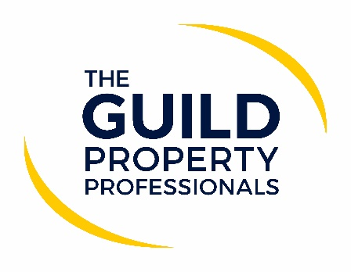

Agents have a moral obligation to do their bit for the country
With the new variant of Covid-19 causing a rapid rise in the infections throughout the country, Prime Minister Boris Johnson announced new measures and a national lockdown to mitigate the spread of the virus to protect the NHS and save lives.

Paul Offley, Compliance Officer at The Guild of Property Professionals, says Government guidance stipulates that people in England are still permitted to move homes and estate and lettings agents can continue to work. However, the announcement is another reminder to the property sector that it is imperative to act within a Covid-secure manner to ensure the safety of both the public and the agents themselves. He adds that the robust Covid-secure polices in place within the property sector have been what has kept the sector and people moving. Policies which are imperative at a time when the rate of infections is on the rise and we are in the throw of another wave. “With the rate of infections increasing once again due to the highly contagious variant of Covid-19 making its way through the country, now more than ever agents have an obligation to continue to act within a safe manner to ensure that they are protecting the public and doing what they can to minimise the spread of the virus,” he says.

“While physical viewings may be permitted by the Government, given the current circumstances and resurgence of the virus, agents should ensure that physical viewings only take place as the very last step once they have gone through much of the process with potential buyers virtually. In fact, I would go as far as to say that in the current situation with the increased rate of infections, agents have a moral obligation to ensure that all buyers are taken through the process of virtually viewing a property before any face-to-face appointment takes place. Buyers should also consider whether there is a genuine need for the appointment to take place now or consider whether the appointment could be deferred until restrictions are eased,” advises Offley.

While many industries have been negatively impacted by the pandemic over the course of 2020 with lockdowns, the Tier system and forced closures, since the reopening of the property market after the initial lockdown, people have continually been allowed to move home and agents have been able to assist them to do so. “As one of the few sectors that have continued to be able to operate, we need to continue to ensure we are acting according to the prescribed health guidelines to help keep both clients and staff members safe during this wave of the virus,” Offley concludes.

Download the Home Moving Guide here.

-ENDS-

Editors’ Notes
The Guild of Property Professionals (The Guild)
The Guild is a network of 800 of the best independent estate agents from across the UK. The Guild is a sign of professional excellence that agents can use to differentiate themselves from their competitors and assure clients that they will act with knowledge and integrity to achieve results, the three core values of The Guild. To allow agents to perform a superior service, The Guild offers marketing, business and technology services to its members.

