Fine & Country MD signs up as an Agents Together mentor

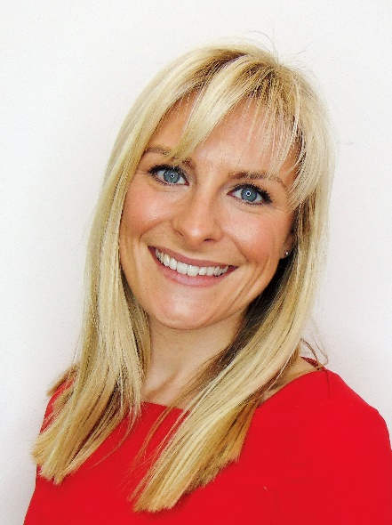
Agents Together, a non-profit organisation, has over one hundred mentors who freely give up their time and share their experiences to help those who are new to the industry progress in their careers. Nicky Stevenson, MD of Fine & Country, speaks about why she wanted to be a part of the initiative.

“I am very grateful to have had people in my career that I would class as mentors, people that have shaped and helped my career to develop over the past 17 years in the property industry. So, when Sarah Edmundson, CEO of Agents Together, discussed with me the mentorship scheme, it was something that I jumped at the chance to do; to give back to others in an industry I love,” says Stevenson.

“My first full time work experience was in an estate agency, straight after my GCSE’s at 16 years old. After the work experience, they immediately offered me a job and my career within the property industry started. I then joined Davis Tate, my manager was a young woman named Claire, who was an inspiration to me. She was a very supportive boss who encouraged me to achieve things I may not have thought possible. The founder of the business, David Tate, is another person I would consider a mentor and someone I have kept in touch with throughout my career. When Fine & Country approached me, he was one of the people I discussed the matter with as a supportive figure, adviser, and mentor,” Stevenson comments. “Estate agency coach, Peter Knight who founded the Property Academy, was also an amazing influence and mentor in my career. All of these people have played a vital role in helping me to get to where I am in my career and being a mentor to someone else coming up the ranks is a huge honour.”

Stevenson adds that one of the best lessons she has learned from her mentors is to have self-belief even when you don’t necessarily feel confident. “When I was a negotiator, my boss wanted me to become a manager and encouraged me to take that next step, even though I didn’t think I was capable of it at the time. There are a lot more examples of times when a mentor has encouraged me to step out of my comfort zone and push myself in my career because they believed in me and what I was capable of, even when I wasn’t sure. It is that encouragement and belief that has kept me moving forward,” she says. “As a mentor, I want to be available as a sounding board and a support for my mentee to be able to talk things through. Hopefully, I will also be able to inspire and encourage them to achieve things they might not have thought they could, helping to instil both confidence and a positive mind set. There is also the aspect of accountability, if that is something the mentee wants from the relationship.”

“Sarah highlighted that there are a lot of young women registering with Agents Together as mentees. If I can help them progress their career within the property sector, then I am delighted to do so. Hopefully, the mentor programme will result in more women breaking into the upper ranks of the industry in the future,” she adds. “I am proud to be a part of the programme and look forward to seeing its growth in future.” Stevenson continues that it is important for younger woman coming into a male-dominated industry to have female role models.

Sarah adds, “It is so important that everyone in our industry recognises that there is someone out there who they can talk to, bounce ideas off, look to for a confidence boost or a new perspective. At Agents Together we have a fantastic group of diverse mentors, over 130 now, and they are willingly volunteering their time to help others. For me this is a real positive to have come out of a truly tumultuous year. To have Nicky as one of our Mentors is fantastic, her career path and experience will inspire not just her mentees but also those who observe her holding a senior position in a very well respected business like Fine & Country. I would encourage everyone to set aside any scepticism or nerves and give mentoring a go for themselves, I know first-hand how rewarding it can be for both Mentor and Mentee."
-END-
Editors Notes:
Fine & Country specialises in the sale and rental of prime residential properties. The company has offices in 300 locations around the world, including in the UK, Cyprus, Ireland, Germany, Mauritius, The Channel Islands, France, Namibia, Portugal, Spain, South Africa, West Africa, Hong Kong, Australia, and Hungary. Fine & Country has won Best Estate Agency Marketing and Best International Estate Agency Marketing seven times in the past ten years at the International Property Awards.

Agents Together is a charitable foundation, funded in its entirety by Michael Bruce and run and operated by Sarah Edmundson and her small team. They aim to help estate agents and property professional achieve a healthy mind and a healthy business through a variety of initiatives, including a mentorship scheme and website hub. To find out more about being a Mentor or being Mentored people can visit; https://www.agentstogether.co.uk/full-mentoring/

