

**01322 666452**

Open 7 Days

www.brookbanksonline.co.uk

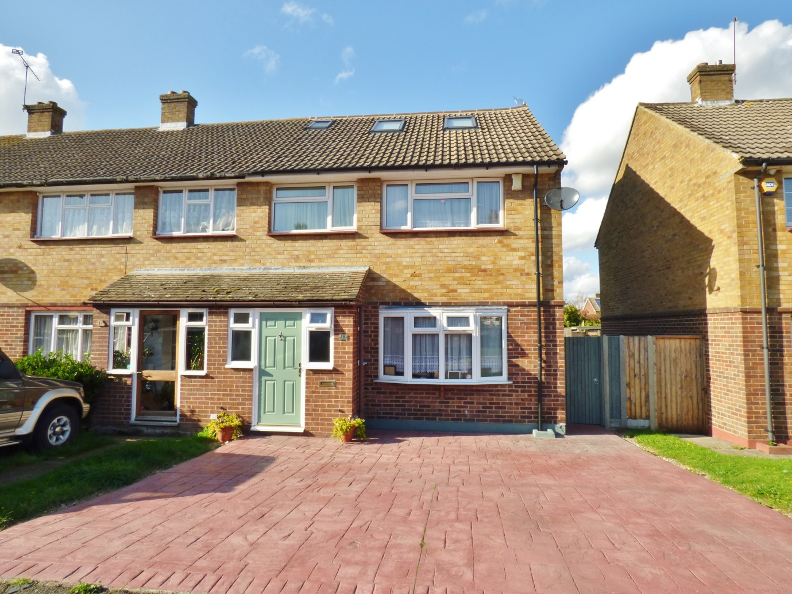

Set in the heart of Swanley and within walking distance of Swanley Train Station, sits this beautiful four bedroom family home. With off street parking to the front, and a detached garage to the rear. Stepping through the porch you are welcomed into the bright spacious lounge boasting an exposed brick archway with a large bay window and feature fire place. Through to the 18ft open plan kitchen/diner complimented with patio doors leading you out to the rear garden, benefiting from a stunning pergola. To the first floor you are greeted with the family bathroom, two double bedrooms and a single, up to the second floor you will find the master suite with an en suite shower room, built in storage and floor to ceiling windows over looking the rear. This family home needs to be viewed to fully appreciate all is on offer here, so please call Brookbanks to arrange your viewing today. £400,000-£425,000

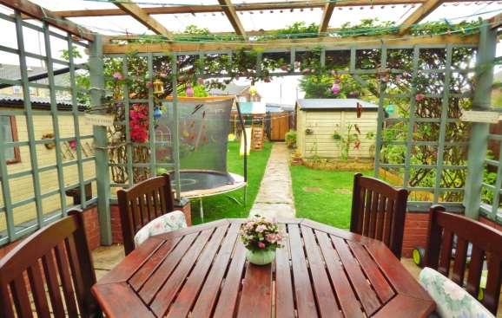

**Guide Price £400,000**

**West Harold**

Swanley, BR8 7EJ

**Entrance Porch**

PVC Door to front, Two double glazed frosted windows to front, window to side.

**Lounge** *18' 6'' x 13' 8'' (5.63m x 4.16m)*

Bay window to front, laminate floor, Understair storage, Brick arch way, Feature fire place, Radiator.

**Kitchen/Diner** *18' 10'' x 11' 2'' (5.74m x 3.40m)*

Tiled floor, Wall and base units with work surfaces over, Double glazed window to rear, Double glazed patio doors to rear, Double drainer sink, Range cooker with gas hob, Space for fridge freezer, Space for washing machine, Space for tumble dryer, Radiator.

**First Floor Landing**

Laminate floor, Storage cupboard.

**Bathroom** *5' 10'' x 7' 8'' (1.78m x 2.34m)*

Tiled Floor, Tiled walls, Paneled bath with shower over, Low level W.C, Vanity sink unit, Two double glazed frosted windows to rear.

**Bedroom One** *17' 4'' x 14' 5'' (5.28m x 4.39m)*

Laminate Floor, Built in eaves storage, Built in wardrobes, Built in storage, Double glazed windows to rear, Two double glazed sky lights, Rad. Radiator.

**Bedroom Two** *12' 9'' x 10' 4'' (3.88m x 3.15m)*

Laminate floor, Double glazed window to front, Fitted wardrobe, Radiator.

**Bedroom Three** *11' 4'' x 10' 7'' (3.45m x 3.22m)*

Laminate floor, Double glazed window to rear, Built in cupboard, Radiator.

**Bedroom Four** *7' 11'' x 7' 1'' (2.41m x 2.16m)*

Laminate floor, Double glazed window to front, Radiator.

**Ensuite** *7' 10'' x 4' 7'' (2.39m x 1.40m)*

Tiled floor, Tiled walls, Walk in shower, Low level w.c, vanity unit sink, Double glazed frosted window to rear, Heated towel rail.

**Garden**

Pergola, Laid to lawn, Paved area, Side access, Rear access, Shed, Garage.

**Driveway**

Parking for two cars, Paved.

**Garage**

To rear.

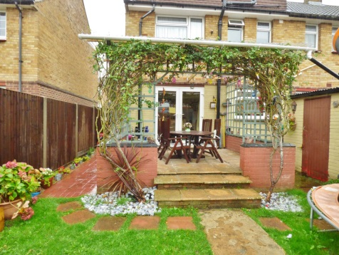

**EPC Rating: TBC**

**Council Tax Band: C**

*Viewers notes...*

Whilst we endeavour to make our sales particulars accurate and reliable, if there is any point which is of particular importance to you, please contact the office and we will be pleased to check the information. Do so particularly if travelling some distance. The mention of any appliances and/or services in these details does not imply that these are in full and efficient working order. Please be advised that some of the particulars may be awaiting vendor approval. Please contact the branch who can provide confirmation if required.

41 High Street, Swanley, Kent BR8 8AE T: 01322 666452

Email: sales@brookbanksonline.co.uk

Website: www.brookbanksonline.co.uk

Managing director Mr D. Williams FNAEA Director & Company Secretary: L. Williams

Registered in England No: 05007887 VAT No: 769 1444 01





41 High Street, Swanley, Kent BR8 8AE T: 01322 666452

Email: sales@brookbanksonline.co.uk

Website: www.brookbanksonline.co.uk

Managing director Mr D. Williams FNAEA Director & Company Secretary: L. Williams

Registered in England No: 05007887 VAT No: 769 1444 01