

**01322 666452**

Open 7 Days

www.brookbanksonline.co.uk

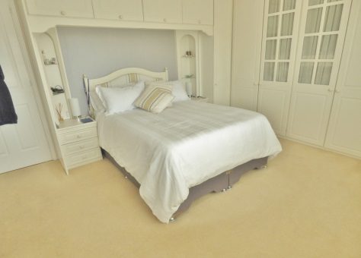

**Guide Price £700,000**

**Archer Way**

Swanley, BR8 7XR

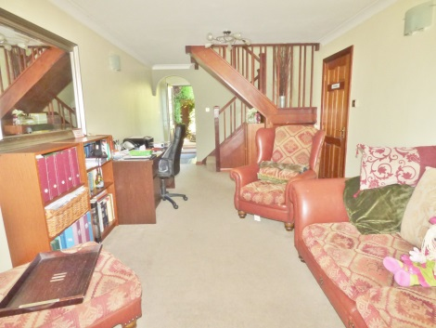

This bright and spacious three bedroom detached home with a one bedroom annex is located in one of the most sought after roads in Swanley, just a short walk to Swanley main line station.

As well as walking distance to a number of highly recommended primary and secondary schools, this could make the perfect family home.

Set back from the road and behind a large driveway suitable for multiple vehicles with an electric vehicle charging point sits this family home.

Inside and through the porch you can move straight in and enjoy the tasteful, relaxing ambience the current owners have created with their décor.

In the main house the 25ft lounge is complemented with French doors leading you out to the beautiful garden, allowing the light to billow through. The remote controlled gas fire is the perfect accessory for those looming winter nights. The kitchen is ready for you to get cooking, with a two ovens and five ring burner. The 17ft dining room complimented with a large bright window makes for the perfect setting this Christmas with enough space to fit the whole family around the table.

Upstairs you will find three double bedrooms. The third bedroom boasts a built in shower, whilst the master bedroom provides fitted wardrobe’s.

To the ground floor you can find a cloak room and to the first floor is a white tiled family bathroom.

Through to the double storey annex you are greeted by the 22ft lounge, leading onto the modern kitchen.

Upstairs you are greeted with a mezzanine style double bedroom, and shower room.

Both properties lead out to the beautiful rear garden. With side access, it has been landscaped with astro turf and patio areas, lined by a number of small mature trees creating a private and peaceful setting. The fish pond leaves the perfect area for entertaining in those warmer evenings. An added bonus at the end of the garden hidden away is a purpose built shed with power and lighting.

Do not miss your chance to view this spacious bright family home.

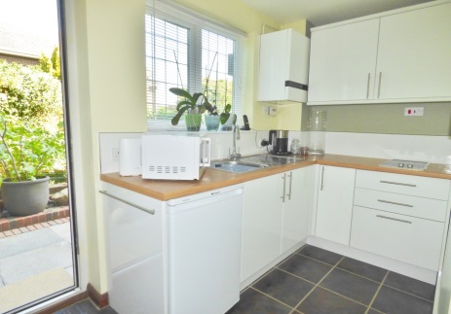

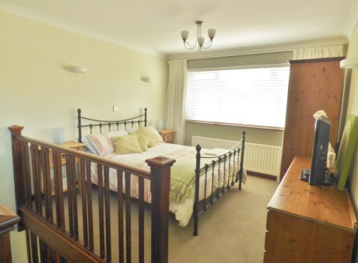

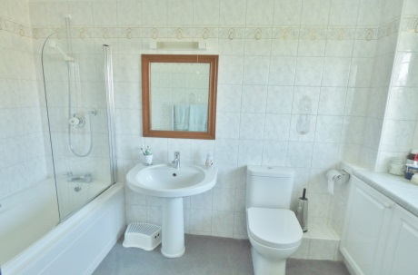

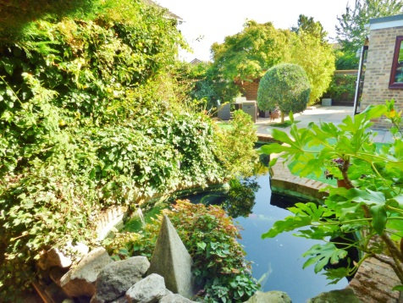

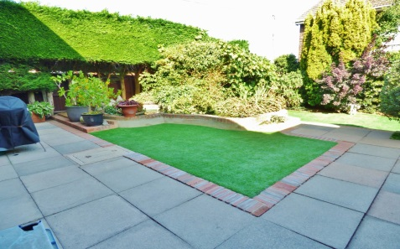

**EPC Rating:**

**Council Tax Band: E**

Whilst we endeavour to make our sales particulars accurate and reliable, if there is any point which is of particular importance to you, please contact the office and we will be pleased to check the information. Do so particularly if travelling some distance. The mention of any appliances and/or services in these details does not imply that these are in full and efficient working order. Please be advised that some of the particulars may be awaiting vendor approval. Please contact the branch who can provide confirmation if required.

41 High Street, Swanley, Kent BR8 8AE T: 01322 666452

Email: sales@brookbanksonline.co.uk

Website: www.brookbanksonline.co.uk

Managing director Mr D. Williams FNAEA Director & Company Secretary: L. Williams

Registered in England No: 05007887 VAT No: 769 1444 01





41 High Street, Swanley, Kent BR8 8AE T: 01322 666452

Email: sales@brookbanksonline.co.uk

Website: www.brookbanksonline.co.uk

Managing director Mr D. Williams FNAEA Director & Company Secretary: L. Williams

Registered in England No: 05007887 VAT No: 769 1444 01