

**01322 666452**

Open 7 Days

www.brookbanksonline.co.uk

**\*CHAIN FREE*FOUR BEDROOMS*FIVE BATHROOMS*DETACHED FAMILY HOME*SEPARATE BARN*QUIET LOCATION*HUGE POTENTIAL*VIEWING IS A MUST\***

**CLEMENT STREET, BR8 7PQ**

**Guide Price: £785,000**

**Are you looking for a rare opportunity to acquire a four bedroom, five bathroom family home with three reception rooms and a separate barn.. Or maybe you are looking for a development opportunity with the potential of building two properties subject to planning permission.**

**You really need to see this property to fully appreciate it. Boasting a private driveway with parking for multiple vehicles, horse stables behind, and fields full of horses to the front set in a quiet location, not overlooked from any direction.**

**With so many possibilities with this property it really can be anything.**

**This is not going to hang around for long, so call Brookbanks now to arrange your viewing.**

**Enclosed Porch**

**Entrance Hall**

**Lounge *23' 4'' x 11' 10'' (7.11m x 3.60m)***

**Sitting Room *132' 2'' x 9' 9'' (40.25m x 2.97m)***

**Study *8' 9'' x 6' 5'' (2.66m x 1.95m)***

**Lobby**

**Bathroom *9' 7'' x 8' 11'' (2.92m x 2.72m)***

**Dining Room *15' 5'' x 9' 4'' (4.70m x 2.84m)***

**Kitchen *12' 4'' x 9' 4'' (3.76m x 2.84m)***

**Landing**

**Bedroom 1 *19' 2'' x 12' 7'' (5.84m x 3.83m)***

**En suite/ Shower room *6' 7'' x 6' 4'' (2.01m x 1.93m)***

**Bedroom 2 *19' 9'' x 12' 3'' (6.02m x 3.73m)***

**En suite *7' 9'' x 7' 2'' (2.36m x 2.18m)***

**Bedroom 3 *16' 8'' x 15' 8'' (5.08m x 4.77m)***

**En Suite *7' 8'' x 7' 7'' (2.34m x 2.31m)***

**Bedroom 4 *14' 4'' x 9' 2'' (4.37m x 2.79m)***

***Ensuite 9’2” x 6’11” (4.37m x 1.83m)***

**Yard to side and rear 65”**

**Ample Parking**

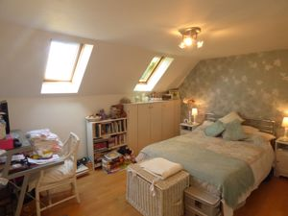

Whilst we endeavour to make our sales particulars accurate and reliable, if there is any point which is of particular importance to you, please contact the office and we will be pleased to check the information. Do so particularly if travelling some distance. The mention of any appliances and/or services in these details does not imply that these are in full and efficient working order. Please be advised that some of the particulars may be awaiting vendor approval. Please contact the branch who can provide confirmation if required.

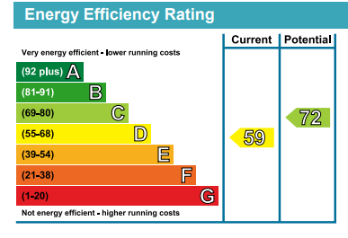

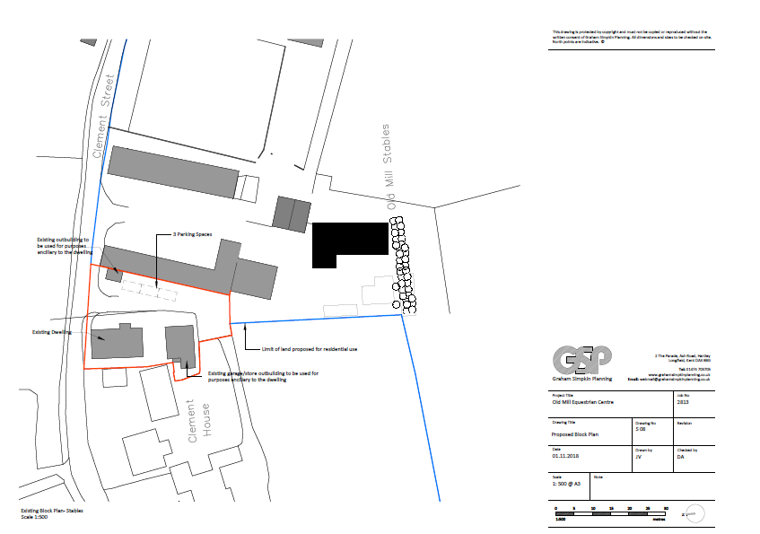

41 High Street, Swanley, Kent BR8 8AE T: 01322 666452

Email: sales@brookbanksonline.co.uk

Website: [www.brookbanksonline.co.uk](http://www.brookbanksonline.co.uk)

Managing director Mr D. Williams FNAEA Director & Company Secretary: L. Williams

Registered in England No: 05007887 VAT No: 769 1444 01