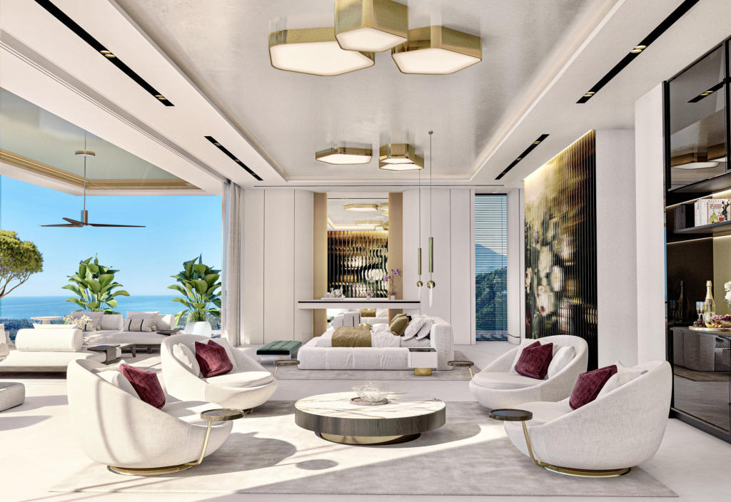
Dream properties

Rightmove | Property News | Property Blo.. by Kristy Gray

Five dream homes abroad
The traffic light system for travel has been replaced with new, simplified rules in the UK, with one red list and a ‘rest of the world’ travel list.
The revised rules will be welcome news to those who want to get their dream of an overseas move back on track.
Trevor Leggett, Chairman of estate agent Leggett Immobilier, says the loosening of restrictions will lead to a leap in viewings and sales of homes in France.
“The French property market is hotter than at any time I can remember. We have pent up demand from British buyers who have not been able to travel easily between the two countries. Be warned though, you will face stiff competition from local buyers, so get your finances in place and be ready to move quickly,” he says.
In the meantime, we thought we’d head off on a dream house hunt and take a peek inside some of the most spectacular homes for sale across Europe right now – from exotic beachfront villas to palatial countryside retreats. Take a look.

1. France
This stunning Hacienda-style luxury villa built into the hills of Saint-Antoin, in Nice, overlooks the hills to the west, and the sea and Cannes to the south-west.
The sprawling eight-bedroom is an architectural masterpiece, with a statement curved staircase in the grand entrance hall and marble floors throughout.
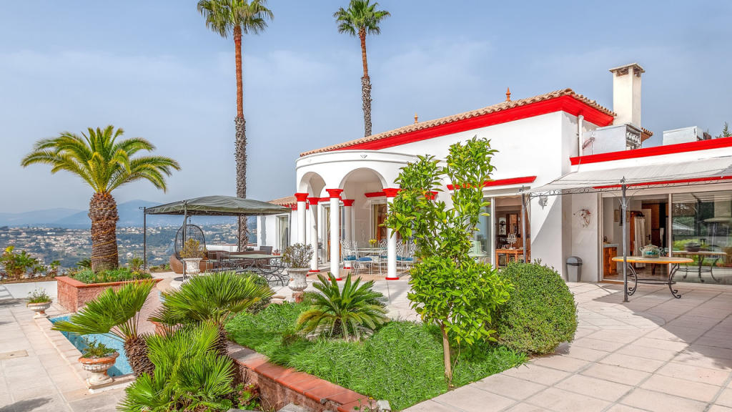
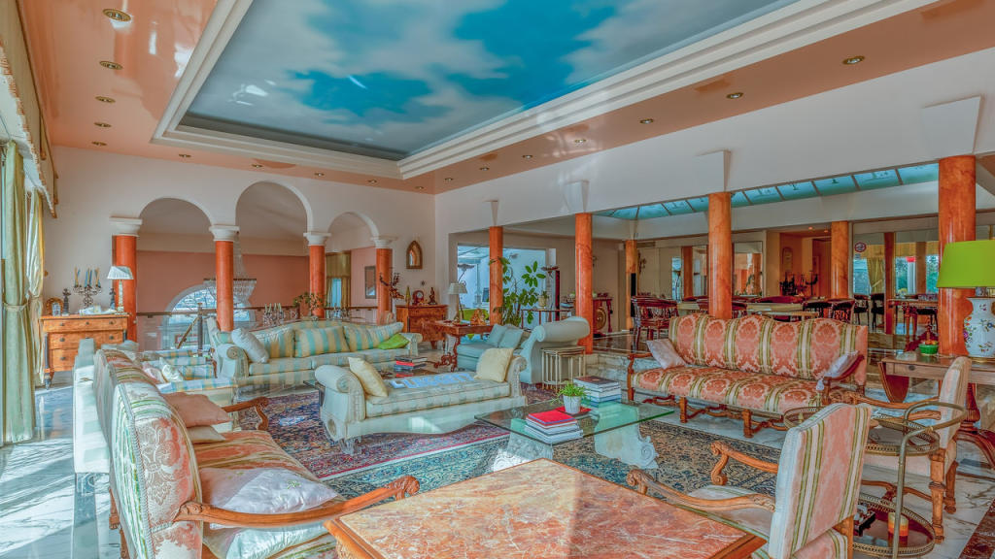

An eight-bedroom luxury villa in Nice Provence-Alps-Cote d`Azur, Alpes-Maritimes, Nice, France €5,500,000

2. Spain
This ultra-luxurious oceanfront villa wouldn’t look out of place in Miami… or the new Bond film.
Big, bold interiors showcase maximalist design, making full use of the home’s epic proportions throughout, with walls of illuminated marble, contemporary stained-glass features and floor-to-ceiling art works.
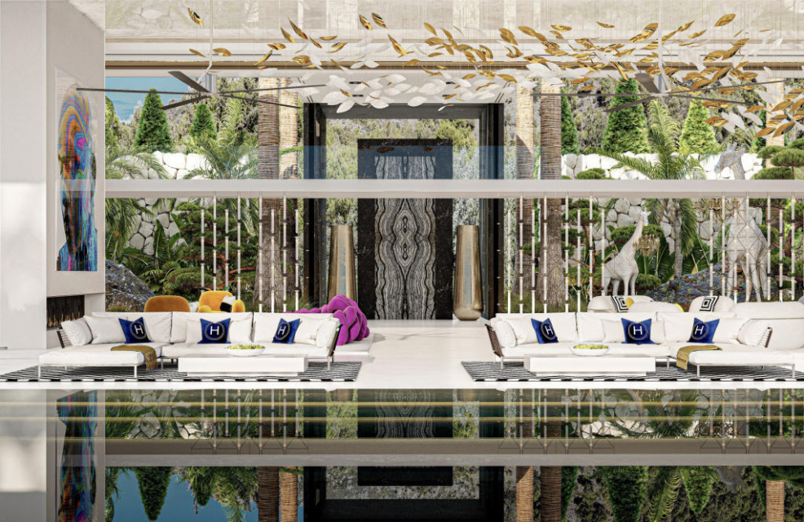
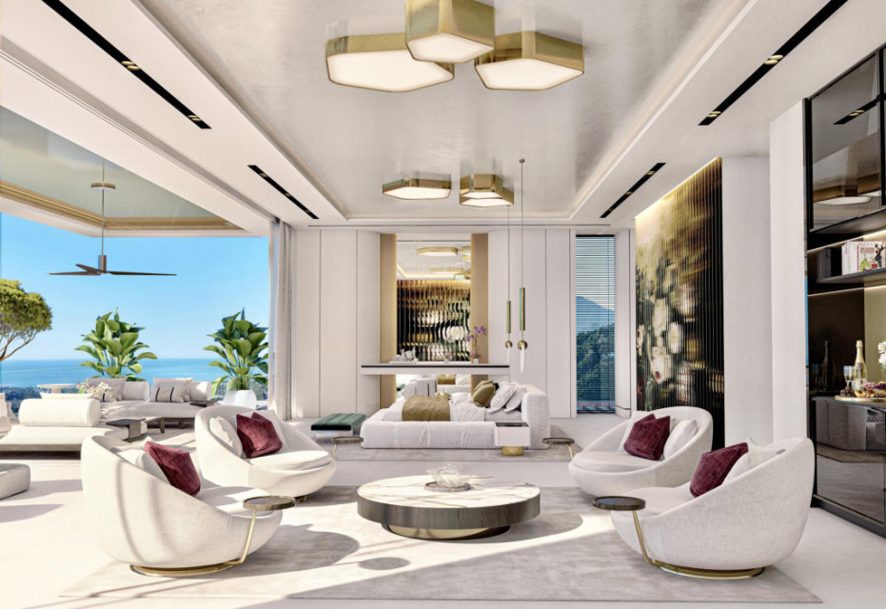

Soaring palm trees surround the property, which, by the way, has not one pool, but two, with water cascading down from the first-floor infinity pool to the pool and terrace area below.
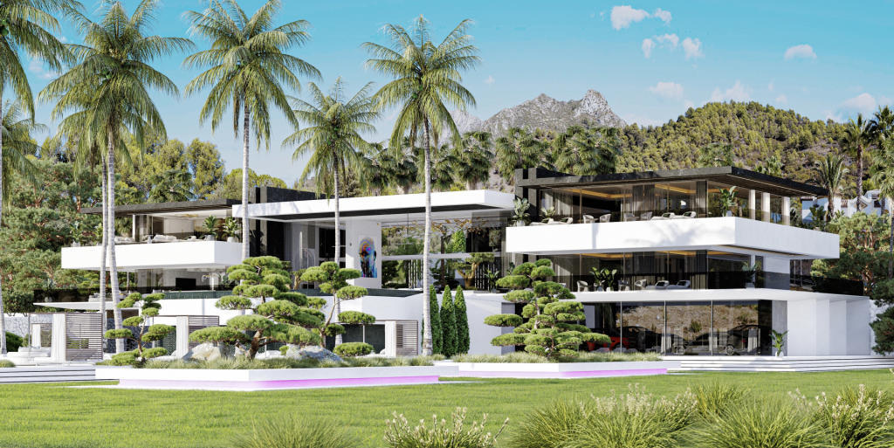
A modern architectural masterpiece in Marbella Andalucia, Malaga, Marbella, Spain €25,000,000

3. Italy
Ever dreamt of living in Italy, making your own wine and producing your own olive oil? This sprawling countryside estate really is the Tuscan dream.
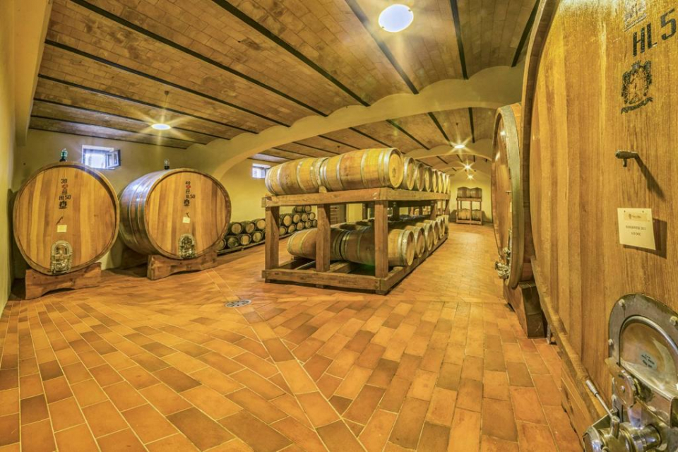
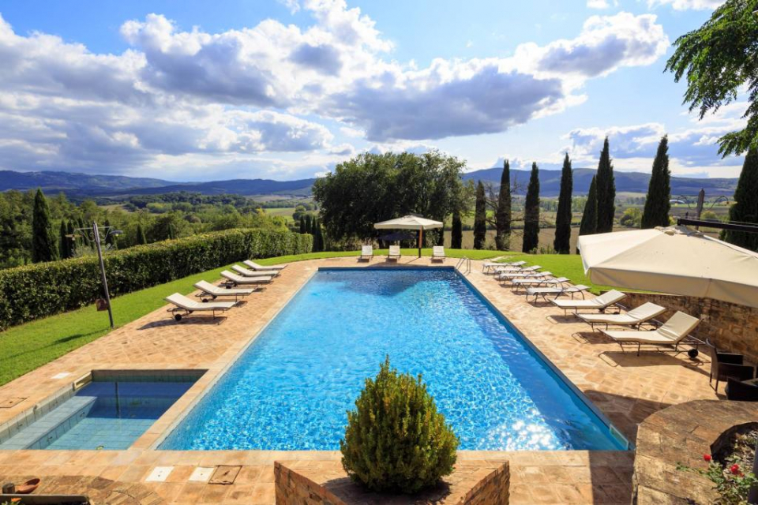

Within the estate there are 17 bedrooms with en-suite bathrooms, four sitting rooms and three apartments. There’s also a pool, bar, jacuzzi, gym, sauna on the extensive grounds.
The property has its own restaurant, 25 acres of vineyards, a wine cantina where the wine is produced and bottled and an olive grove.
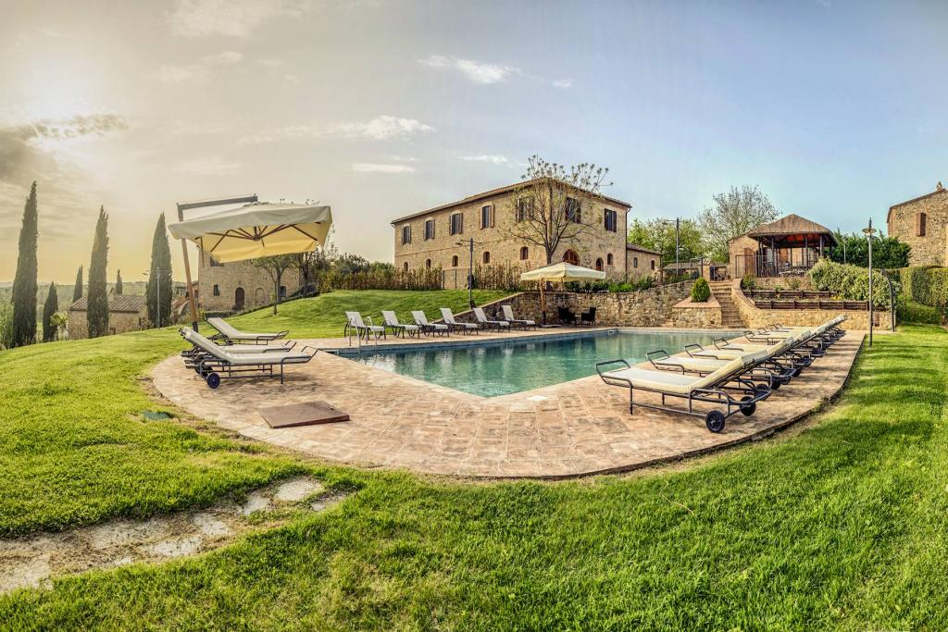
A countryside haven in Tuscany Tuscany, Siena, Siena, Italy €13,500,000

4. Portugal
This contemporary home in the Algarve is within walking distance to the stunning sandy beaches of Vale do Lobo.
Set over three floors, there is plenty of space for guests with seven bedrooms and nine bathrooms.

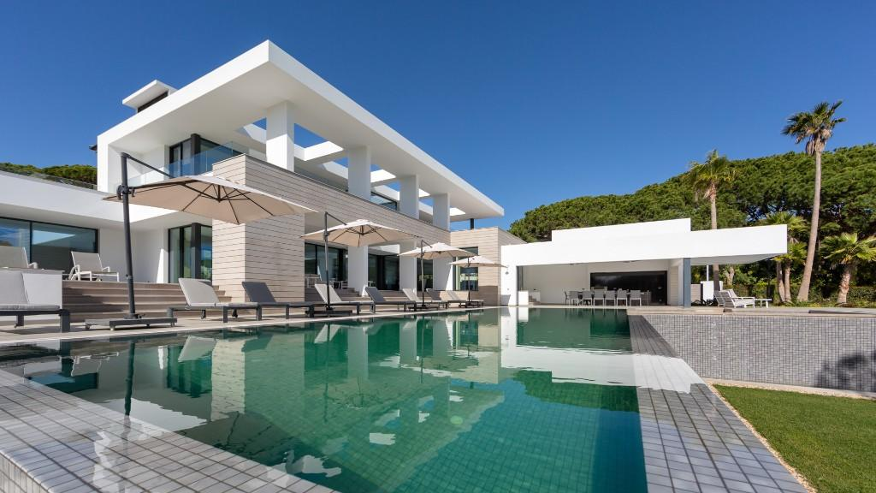
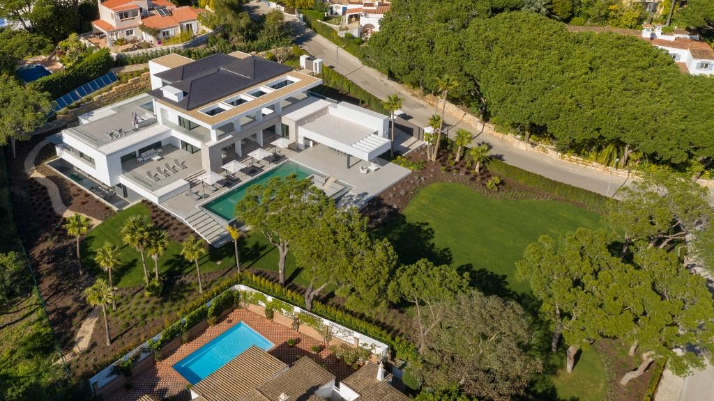
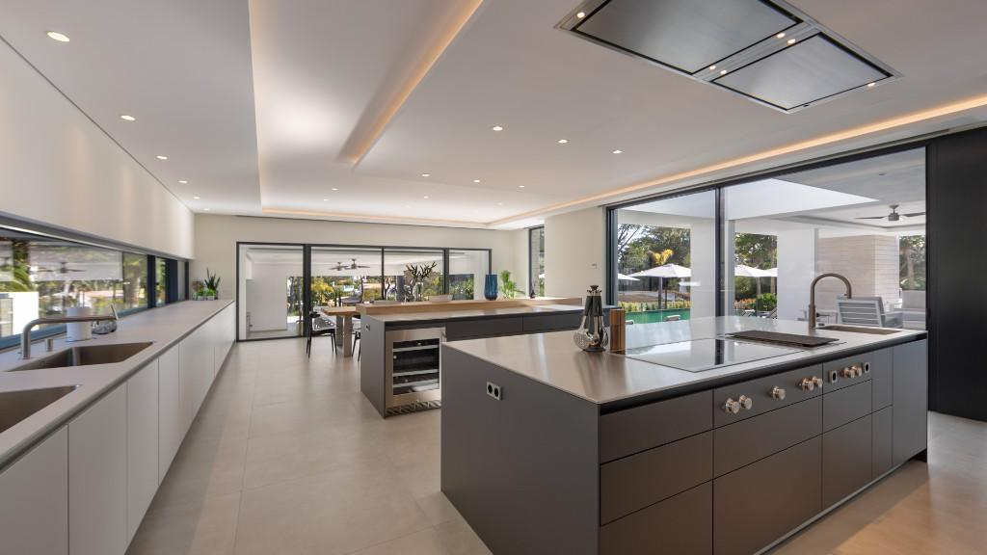

The outdoor space will make you the ultimate host, with a south-facing pool deck, heated infinity pool, a choice of sitting areas, BBQ area, pool side fire pit and sprawling gardens.
A contemporary beach villa in Vale do Lobo Algarve, Portugal €10,950,000

5. Greece
Set along the coast of Porto Heli, a Greek resort town, Villa Splendide really is a slice of paradise in Peloponnese.
With steps leading directly down to a private cove, you can spend summer days swimming in the clean, crystal clear waters, or laze by the pool and take in the sea and mountain views.
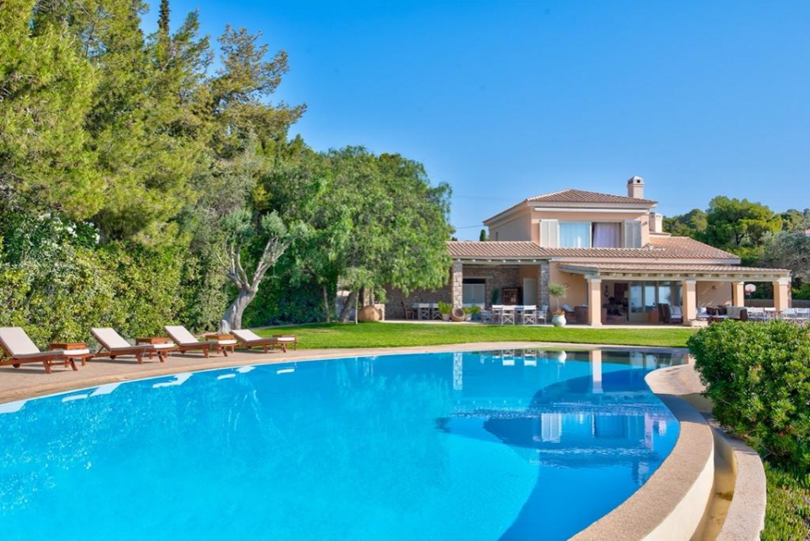
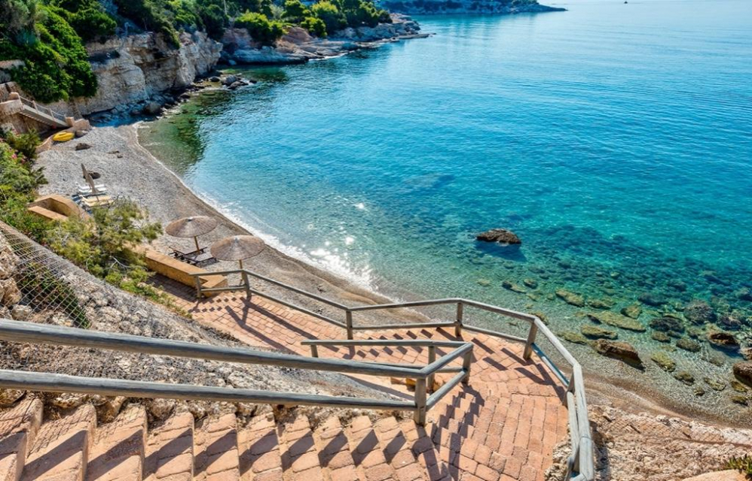
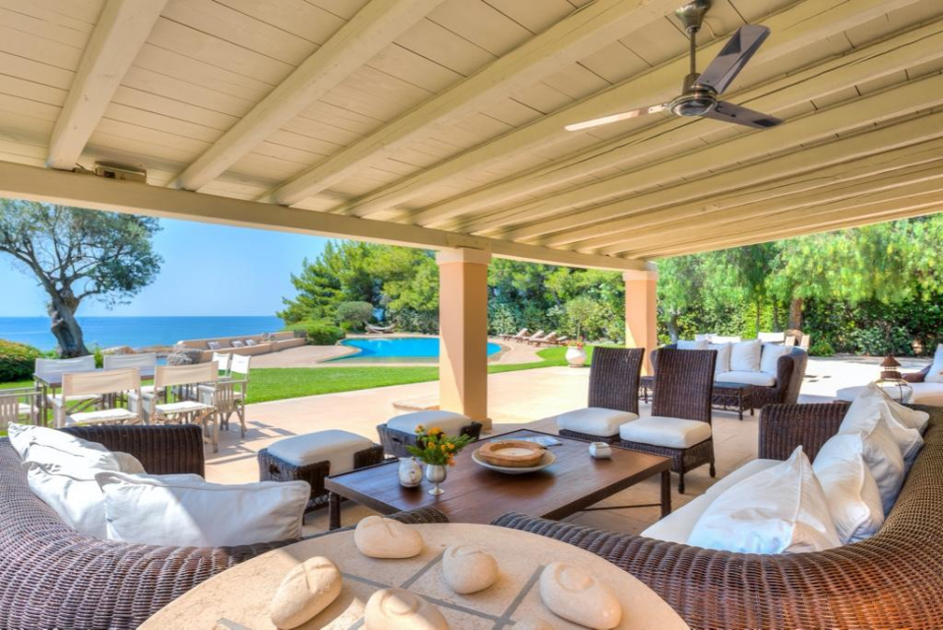

The eight-bedroom, eight-bathroom home has plenty of space, with a huge outdoor dining area you won’t want to leave.
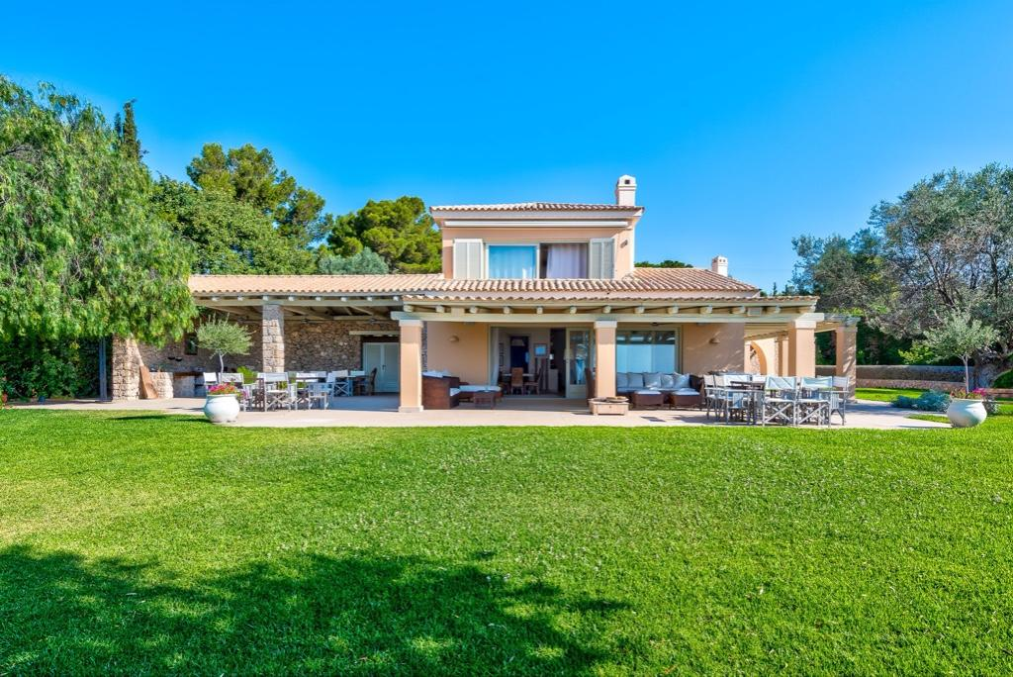
Villa Splendide St. Emilianos, Argolis, Peloponnese, Greece €7,500,000

